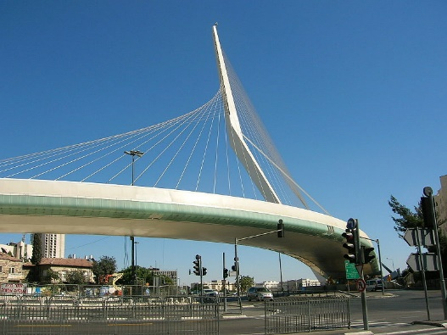Mordy Schaffel

Mr. Lowe

Engineering 110

August 26, 2015

The Chords Bridge in Jerusalem, Israel

Located at the entrance of Jerusalem stands the Chords Bridge, the Bridge of Strings, or the *Gesher HaMeitarim* in Hebrew. The bridge was built by the Spanish architect, Santiago Calatrava, to enhance the city’s skyline and to relieve the hectic traffic of the new light rail train. Construction of the bridge started in 2005 and it was inaugurated on June 25, 2008. However, the service of the bridge only began on August 19, 2011. The cost of the project for this 387 ft. high bridge was about $70 million. The curved bridge has a length of 1,180 ft. and is 48.6 ft. wide. The sixty-six steel cables on the bridge’s 520 ft. span is counterbalanced by a single angled pylon. The bridge was constructed from steel and reinforced concrete and covered mostly in Jerusalem stone with steel, glass, and concrete detailing.

[https://upload.wikimedia.org/wikipedia/commons/thumb/2/25/Bridge-harp-cable-stayed.svg/180px-Bridge-harp-cable-stayed.svg.png](https://en.wikipedia.org/wiki/File:Bridge-harp-cable-stayed.svg)[https://upload.wikimedia.org/wikipedia/commons/thumb/0/0f/Bridge-fan-cable-stayed.svg/180px-Bridge-fan-cable-stayed.svg.png](https://en.wikipedia.org/wiki/File:Bridge-fan-cable-stayed.svg)[https://upload.wikimedia.org/wikipedia/commons/thumb/5/57/Bridge-suspension.svg/180px-Bridge-suspension.svg.png](https://en.wikipedia.org/wiki/File:Bridge-suspension.svg) This unique bridge is a cantilever spar cable-stayed bridge. Cantilever means that the structure extends horizontally further than its vertical support. The spar is the pylon or beam from which the cables protrude. The Chords Bridge is a cable-stayed bridge, not a suspension bridge which has a cable on each side that runs along the span of the bridge with other cables hanging down to hold the up the bridge. A cable-stayed bridge is a bridge where the cables come out of a tower or beam to hold up the bridge. There are two types of cable-stayed bridges; the fan design and the harp design. In the fan design all the cables attach to the beam or tower in the same place. The harp design has the cables spaced out on the beam or tower. The Bridge of Strings is of the harp design and according to Calatrava looks like one to symbolize King David’s harp in Israel’s history.